Kyle Matheson T00153296

COMP1131 Assignment 4 Classes

Question 1: Monkey

Test Case:

1. Test enter \n
2. “u” to extents

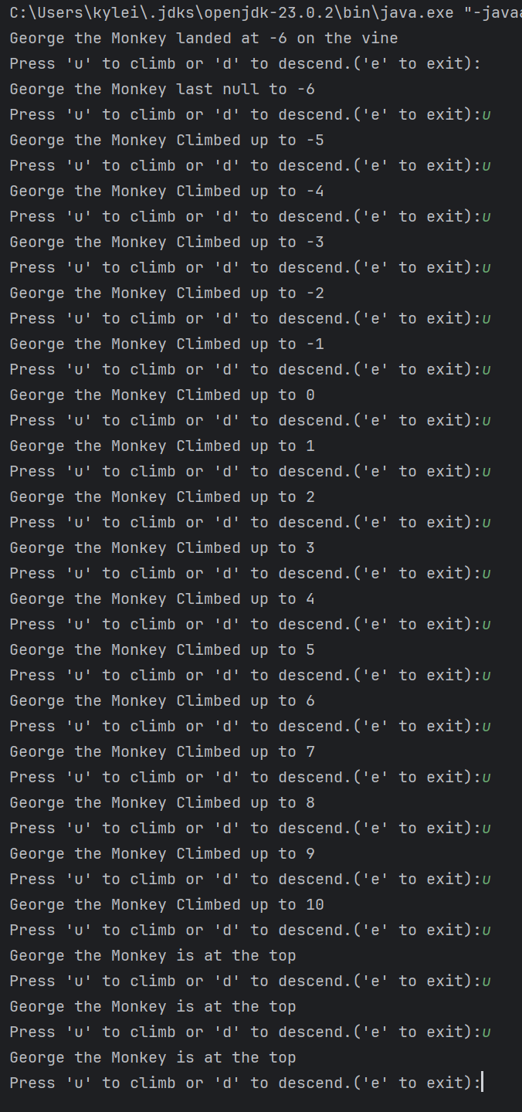

1. “d” to extents

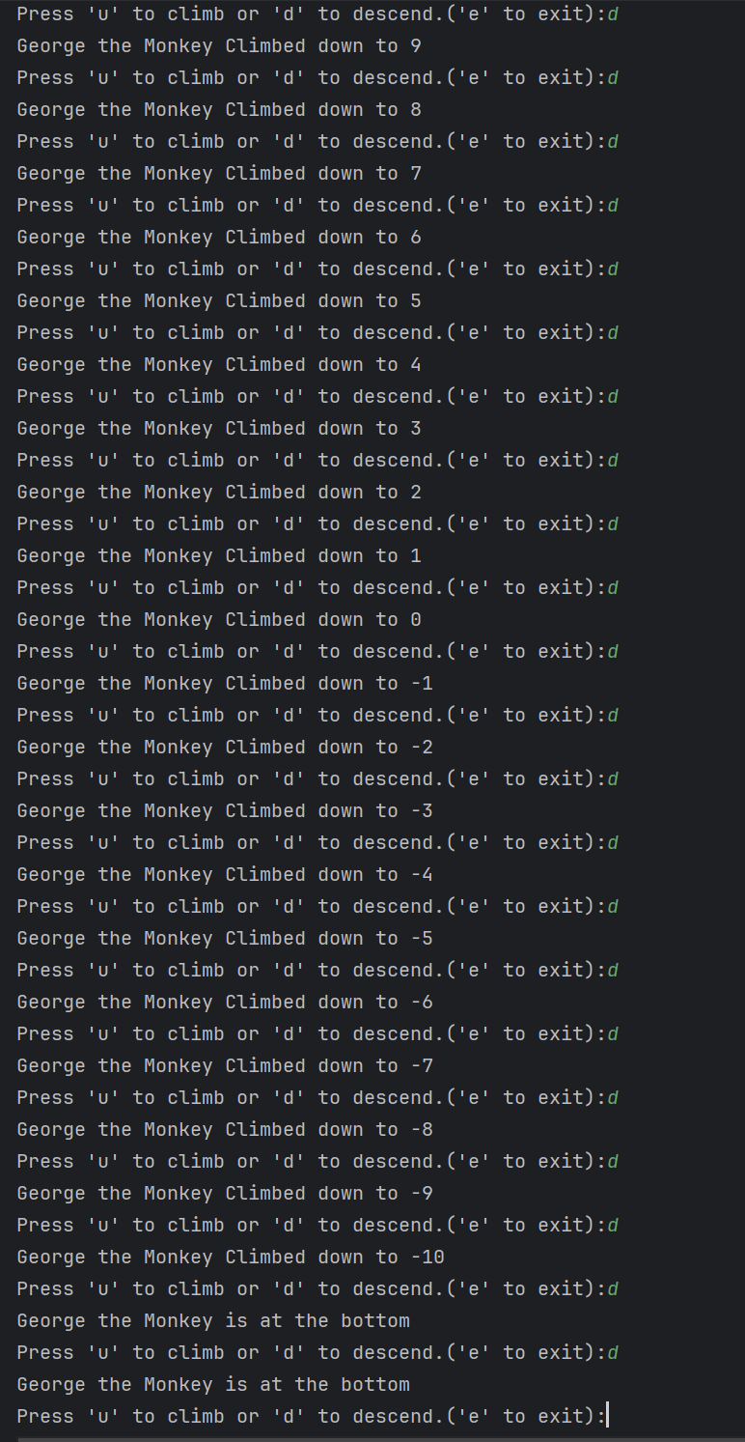

1. “e” to check clean exit
2. 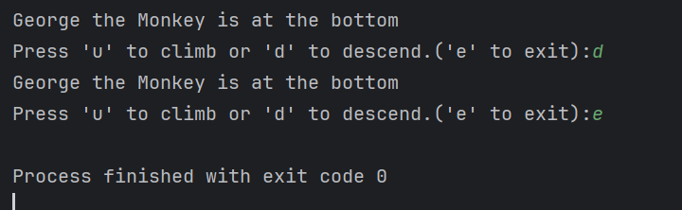
3. U,u,u,d,u,u to test direction change
4. D,d,d,u,d,d to test inverse

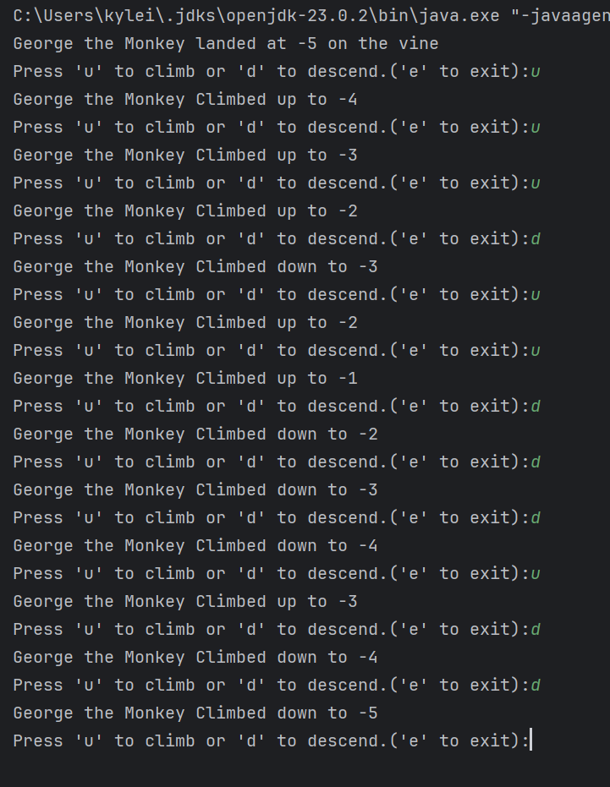

1. “du” to validate first char only
2. “ud” to test inverse
3. “ed’ to test clean exit

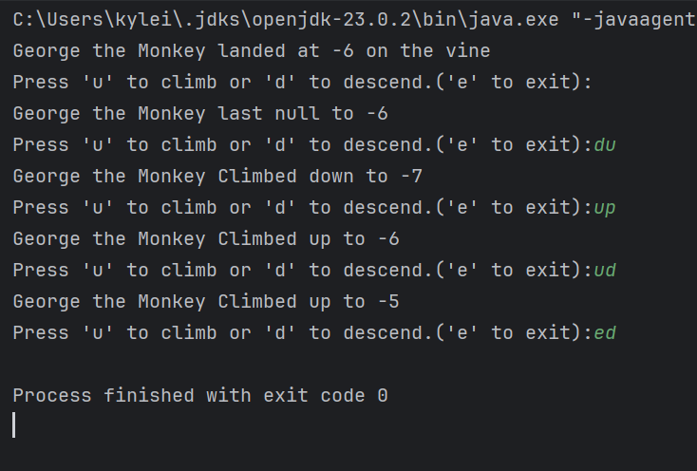

1. “@#+UudDe” to check ignore invalid
2. “random String with spaces” to check ignore invalid

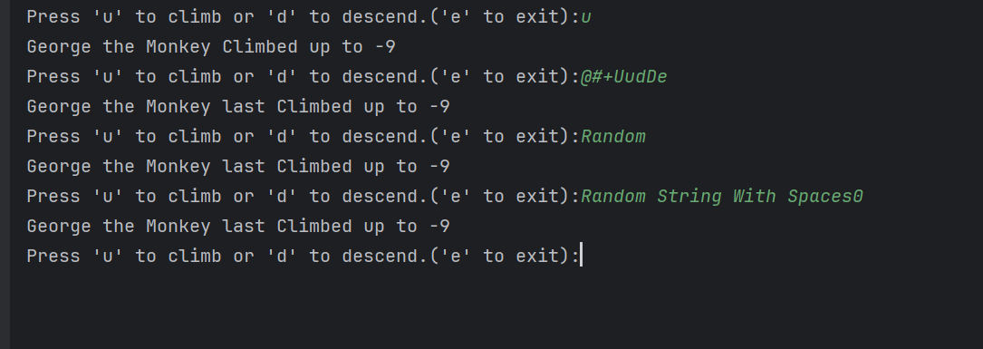

1. Vine Range Correct

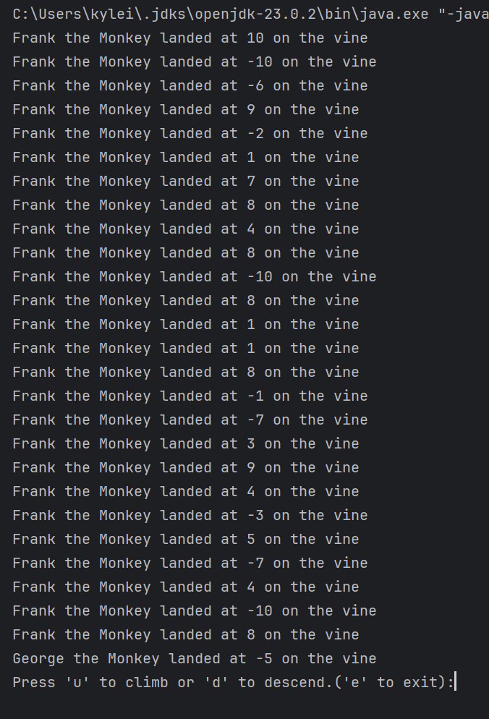

Question 2: Modified Snake Eyes

